2022 iSWP Phase 3 Updates

# 1 Shapefile Updates

We have updated the iSWP’s polygon shapefile so that the sources ‘direct reuse’ (MapSourceId = 169), ‘other local supply’ (MapSourceId = 412), and ‘atmosphere’ (MapSourceId = 820) are now mapped to the state level. The updated shapefile is included with the 2022 iSWP phase 3 documentation. It is in the zip file named ‘2022iswp_swsourcefeatures_poly+Update’. The line and point shapefiles did not change.

# 2 WMS Project Page Update

https://2022.texasstatewaterplan.org/project

There are 22 WMS projects that are not assigned to a specific WUG, they are associated with only “unassigned supply” project sponsor supply. These types of projects display in the WMS project page but have no WUGs listed with them. An example of this type of project is ‘College Station ASR (Reuse).’ These types of projects will not have water user group population data associated with them. We would like to update the message located in the red rectangle shown in Image 1 below to explain this situation better. The new message will be “This project is not assigned to a specific WUG. To see more information about the project and its related WMS supply, click the following link to go to a TWDB webpage containing an Excel workbook summary of the 2022 State Water Plan data which includes that information <http://www.twdb.texas.gov/waterplanning/data/rwp-database/index.asp>. You can also contact [wrpdatarequests@twdb.texas.gov](mailto:wrpdatarequests@twdb.texas.gov) to request information about this project.”

Image

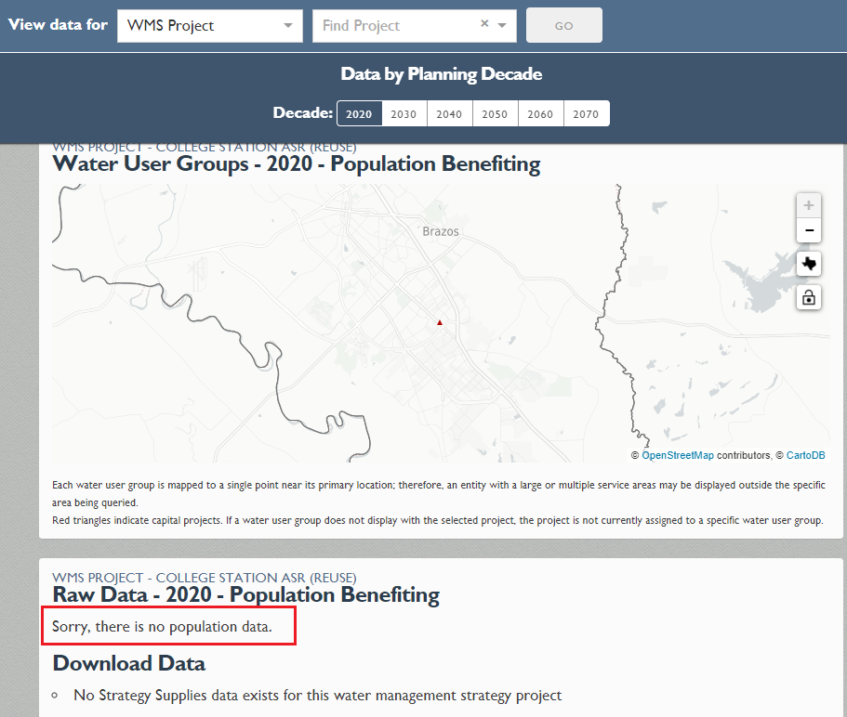

# 3 About Page Text Edits

<https://2022.texasstatewaterplan.org/about>

3.1 ‘How do I find the information I’m looking for?’ section: Remove the last sentence highlighted in the red rectangle shown in Image 2 below and replace it with the following new sentences: “To find information related to WWPs and unassigned water volumes, click the following link to go to a TWDB webpage containing an Excel workbook summary of the 2022 State Water Plan data which includes that information <http://www.twdb.texas.gov/waterplanning/data/rwp-database/index.asp>. You can also contact [wrpdatarequests@twdb.texas.gov](mailto:wrpdatarequests@twdb.texas.gov) to request these types of datasets.”

Image

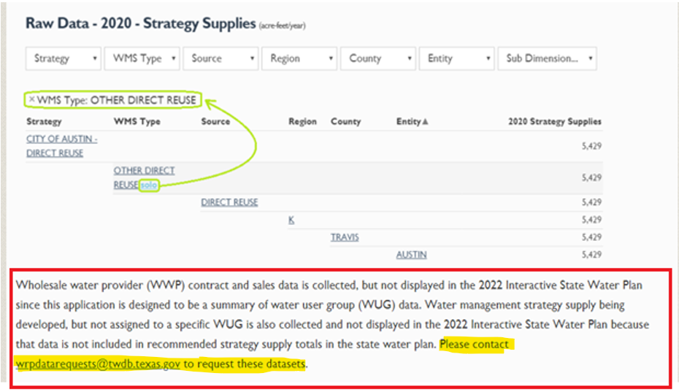

3.2 ‘How do I use the interactive map?’ section: Remove all highlighted text after the first sentence for the bullet in the red rectangle shown in Image 3 below. The new version of the bullet should read “’Direct Reuse’, ‘Local Surface Water Supply’, “Atmosphere’, and ‘Rainwater Harvesting’ are sources that have their data summarized at the statewide level.” Also, remove the messaging that displays for MapSourceIds: 169, 412, and 820 since the sources will now be mapped with the shapefile updates (see Image 4).

Image

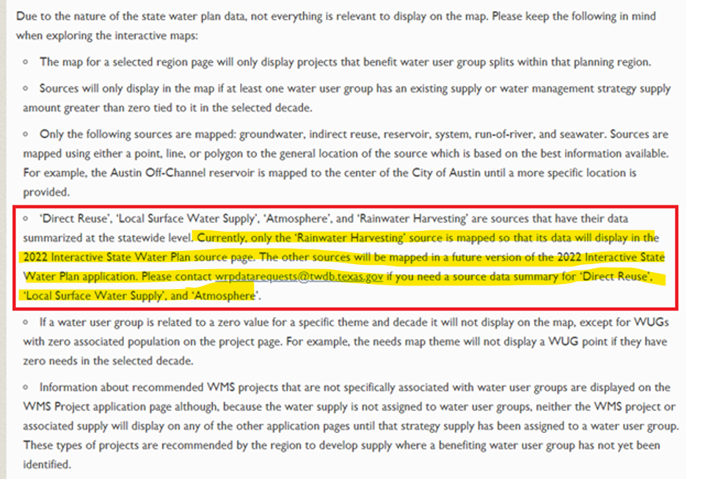

Image

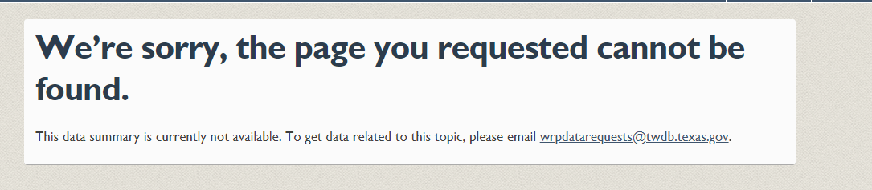

3.3 ‘Where can I access current and previous state water plans?’ section: Directly below the red rectangle shown in Image 5 below, please add a line that says: “Looking for an Excel workbook containing a summary of the 2022 State Water Plan data? Click the following link to go to a TWDB webpage where it is stored <https://www.twdb.texas.gov/waterplanning/data/rwp-database/index.asp>.”

Image

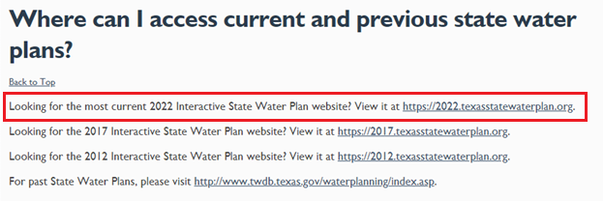

# 4 Pie Chart Labeling

The pie chart in image 6 is difficult to read because it has dark colors for the pie slices and dark text in labels. The labels on the smaller slices also overlap in some cases. Can you think of a way to improve the labeling of this chart so that it is easier to read?

Image 6

